**SQL Case Study 2: Burger Bash**



**INTRODUCTION:**

I have a started a new business of selling burger because I read on my Instagram feed that „Burger Is the Future!

But I knew that burger alone was not going to help me get seed funding to expand my new Burger Empire - so I had one more genius idea to combine with it - I was going to Uberize it - and so Burger Runner was launched!

I started by recruiting “runners” to deliver fresh burger from Burger Runner Headquarters and also maxed out my credit card to pay freelance developers to build a mobile app to accept orders from customers.

**SCHEMA USED**

**burger_runner** runner_id int registration_date date

**customer_orders**

order_id int

customer_id int

burger_id int

exclusions varchar

extras varchar

order_time timestamp

|  |  |
| --- | --- |
| **runner_orders** | |
| order_id | int |
| runner_id | int |
| pickup_time | timestamp |
| distance | varchar |
| duration | varchar |
| cancellation | varchar |

|  |  |
| --- | --- |
| **burger_names** | |
| burger_id | int |
| burger_name | varchar |

**CASE STUDY QUESTIONS**

1. **How many burgers were ordered?**

SELECT COUNT(*) AS total_burgers_ordered

FROM customer_orders;



1. **How many unique customer orders were made?**

SELECT COUNT(DISTINCT order_id) AS unique_orders

FROM customer_orders;



1. **How many successful orders were delivered by each runner?**

SELECT runner_id, COUNT(*) AS successful_orders

FROM runner_orders

WHERE cancellation IS NULL

GROUP BY runner_id;



1. **How many of each type of burger was delivered?**

SELECT bo.burger_name, COUNT(*) AS total_delivered

FROM customer_orders co

JOIN burger_names bo ON co.burger_id = bo.burger_id

JOIN runner_orders ro ON co.order_id = ro.order_id

WHERE ro.cancellation IS NULL

GROUP BY bo.burger_name;



1. **How many Vegetarian and Meatlovers were ordered by each customer?**

SELECT co.customer_id, bn.burger_name, COUNT(*) AS burger_count

FROM customer_orders co

JOIN burger_names bn ON co.burger_id = bn.burger_id

GROUP BY co.customer_id, bn.burger_name;

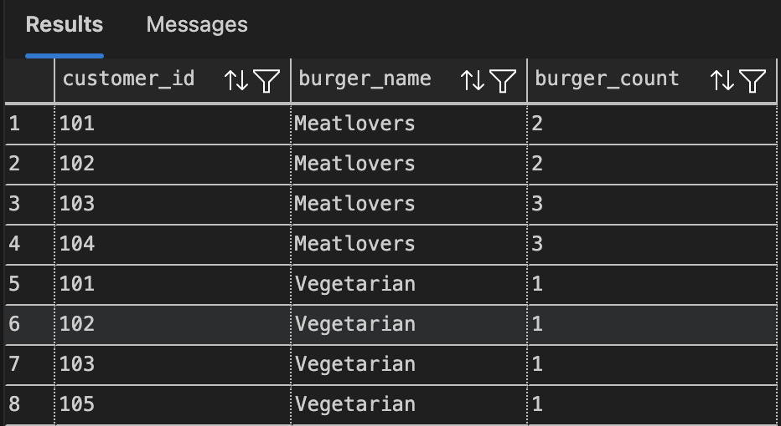

1. **What was the maximum number of burgers delivered in a single order?**

SELECT TOP 1 order_id, COUNT(*) AS burger_count

FROM customer_orders co

JOIN runner_orders ro ON co.order_id = ro.order_id

WHERE ro.cancellation IS NULL

GROUP BY co.order_id

ORDER BY burger_count DESC;



1. **For each customer, how many delivered burgers had at least 1 change and how many had no changes?**

SELECT customer_id,

SUM(CASE WHEN exclusions IS NOT NULL OR extras IS NOT NULL THEN 1 ELSE 0 END) AS changed_burgers,

SUM(CASE WHEN exclusions IS NULL AND extras IS NULL THEN 1 ELSE 0 END) AS unchanged_burgers

FROM customer_orders co

JOIN runner_orders ro ON co.order_id = ro.order_id

WHERE ro.cancellation IS NULL

GROUP BY customer_id;



1. **What was the total volume of burgers ordered for each hour of the day?**

SELECT DATEPART(HOUR, order_time) AS order_hour, COUNT(*) AS total_burgers

FROM customer_orders

GROUP BY DATEPART(HOUR, order_time)

ORDER BY order_hour;

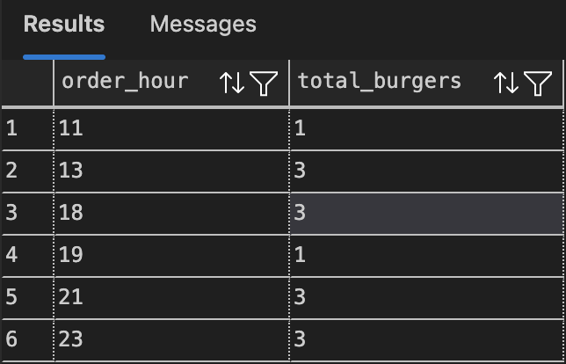

1. **How many runners signed up for each 1 week period?**

SELECT

DATEADD(WEEK, DATEDIFF(WEEK, 0, registration_date), 0) AS week_start,

COUNT(*) AS runners_signed_up

FROM burger_runner

GROUP BY DATEADD(WEEK, DATEDIFF(WEEK, 0, registration_date), 0)

ORDER BY week_start;



1. **What was the average distance travelled for each customer?**

SELECT co.customer_id,

ROUND(AVG(CAST(REPLACE(ro.distance, 'km', '') AS FLOAT)), 2) AS avg_distance_km

FROM customer_orders co

JOIN runner_orders ro ON co.order_id = ro.order_id

WHERE ro.cancellation IS NULL

GROUP BY co.customer_id;

